LITERACY ALIVE 4

READING AND WRITING ADVENTURE CAMP

ROTARY INTERNATIONAL GLOBAL GRANT PROJECT 2018

GLOBAL GRANT # 1754696

INFORMATION PACKAGE
Nov. 2017 Update

CONTENTS:
- Project overview
- Literacy Alive Model Described
- Itinerary of Canadian Vocational Training Teams (March and August 2018)
- Belize Promotion for Involvement of Teachers and Students
- Vocational Training Team Members

LITERACY ALIVE 4
READING AND WRITING ADVENTURE CAMPS IN BELIZE 2018

This Global Grant project is an evolution of many previous literacy projects developed between the Rotary Clubs of Red Deer, Alberta Canada and San Ignacio, Belize over the past six years. The project provides quality resources and coaching on effective literacy strategies for Belize educators and volunteers. Many lessons have been learned from previous projects and this initiative was designed to be the best project so far! Literacy Alive 4 is supported by the Ministry of Education, Cayo, Belize, the Government of Canada and Rotary Canada, Rotary District 5360, Rotary International and many dedicated literacy volunteers in both Alberta, Canada and Belize. This project involves Canadian literacy and community development experts working in teaching teams consisting of Belize educators, public librarians, women in the community and local volunteers. The adult participants provide a stimulating day camp for Belize children between the ages of 9 – 12. The camp provides activities that promote reading, writing and wellness. A Vocational Training Team (VTT) and a companion Voluntravel (open to interested participants) group will lead all activities. The VTT group has been selected, as of September 1, but vacancies exist in the Voluntravel initiative. Refer to other documents in this handout and additional information is available on the project website (including videos) at: literacyalive.ca

Dr. Lynne Paradis
International Director, Rotary Club of Red Deer, AB. CANADA

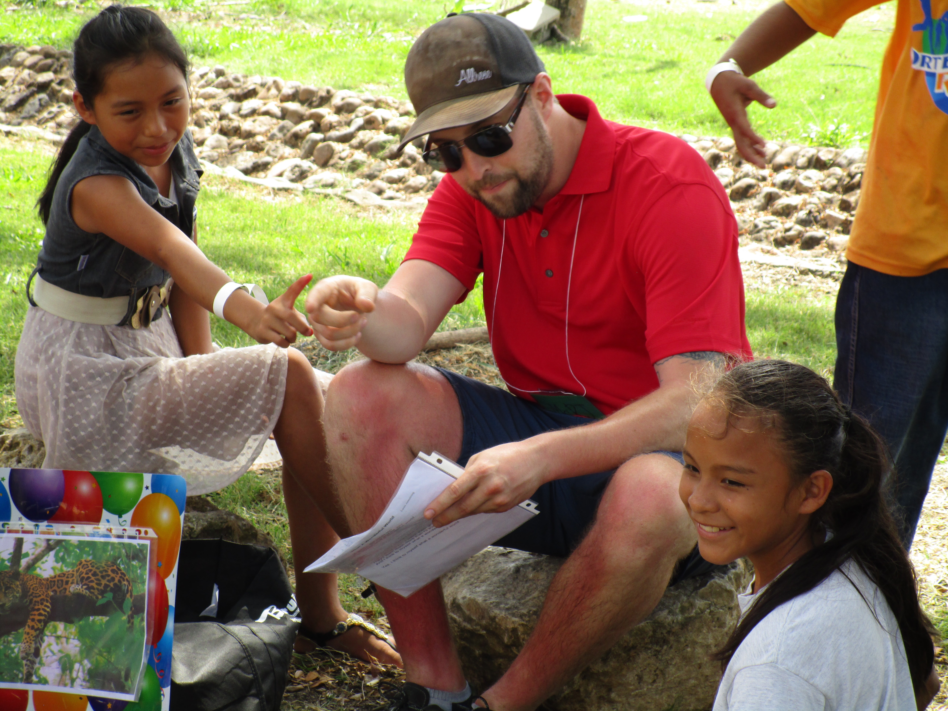

LITERACY ALIVE MODEL

This model was developed as an outcome of several years of literacy volunteer work by literacy experts between Belize and Alberta, Canada. Most of this work was part of Rotary sponsored activities. This model reflects lessons learned and incorporates current educational research on effective literacy learning. A pilot of the model has been field tested (Literacy Alive III global grant project, 2015). This model includes the recommendations from the pilot implementation.

1. RATIONALE

Effective strategies to teach reading and writing exist. Strong teachers use effective strategies that can be learned through professional development activities. Teachers are more likely to implement specific strategies in daily instruction when they have been shown the strategies and have had an opportunity to practice the strategies. Volunteers, parents and other non-trained teachers can be strong supporters of literacy learning if they are provided with focused instruction on literacy learning strategies. These strategies can support literacy efforts in schools and can be used in community libraries and by parents to support increased success in literacy.

Literacy learners are more successful in improving reading and writing skills when they are engaged in activities that are: a) age and level appropriate, b) include topics of personal interest, c) are sequential and broken into small steps, d) developed in system that builds on previous concepts and e) linked to personal experiences of the learner.

2. BELIZE CONTEXT

A need exists to provide Belize communities with:
- Literacy teaching strategies that are research supported for classroom teachers and educational leaders
- Adaptable resources to support literacy learning that are cost efficient and adaptable to various age/grade levels
- Student opportunities for literacy learning activities that are highly engaging and stimulate individual interest and commitment to further success in reading and writing
- Literacy learning resources that are diverse, culturally appropriate and reflect the interests and experiences of students

3. LITERACY READING, WRITING AND ADVENTURE CAMP

The concept of a LITERACY CAMP was developed to create a learning environment where a large group of students would be engaged in intense literacy learning provided by a cohort of literacy experts.

The CAMP provides:
- A model for Belize participants that could be replicated in individual schools, local towns and villages or across a district. This could be done as part of camps on school vacations or as part of a literacy focused theme initiative in schools (eg. Reading and Writing Residency Week).
- Belize educators and volunteers are given the opportunity to observe Canadian literacy experts teaching Belize students and MODELLING effective use of literacy learning strategies utilizing quality teaching resources developed by the expert team.
- Belize educators and volunteers opportunity to teach Belize students using the strategies observed with the support of the Canadian experts serving in a coaching and mentorship role.

4. INSTRUCTIONAL APPROACH (PEDAGOGY)

Adult Learning Dimension

A cohort of at least 20 literacy experts forms the Literacy Vocational Training Team.
Each literacy leader is assigned to ONE of the following Literacy Learning Topic Teams:
- Phonics
- Writing
- Comprehension
- Reading
- Sport and Wellness – these are activity based events to engage students and will provide discussion and topics for inclusion in the reading and writing components of the camp activities.

A cohort of Belize teachers, public librarians, educational leaders and community volunteers forms the Belize Literacy Learning Cohort. These individuals are assigned to one of the Topic Teams and work with the Canadian literacy leader for the duration of the four-day camp. These individuals will become confident in the context and delivery of the literacy teaching strategies and the adaptation of the resources to meet individual student needs. Belize participants will also get an opportunity to visit other topic teams throughout the camp experience to become familiar with all topics and resources used in the camp.

Belize participants witness teaching and learning strategies with Belize students and get the opportunity to practice the strategies with real students – a significant learning strength not possible with most professional development (where students are not present).
Each Literacy Learning Team will ideally have at least five Belize participants coached and mentored by one Canadian expert leader.
The cohort coaching and mentorship model results in significant sharing of literacy teaching strategies in home, school and community (via public libraries) as noted below:

Project Model Benefits
20 Canadian Literacy Leaders
20 teams providing instruction to 20 students 400 students
Each leader trains at least 5 Belize adults 100 adults

100 trained Belize adults return to local schools and
communities and can possibly impact 20 students each 2000 students
100 trained Belize adults share learning with
10 other teachers/adults 1000 adults

Student Learning Dimension

All student participants will rotate each day to various topic stations. The Sport and Wellness station includes games and activities to support student wellness and motivate students to appreciate the values of healthy bodies and healthy minds. This station has games and fun components that serve as a springboard to topics that are developed in the phonics, writing, comprehension and reading stations.

5. LITERACY AWARENESS PUBLIC CELEBRATION

A project public celebration forms part of the CAMP week. Student and adult participants will share a music/dance performance that celebrates literacy as a lifelong learning commitment and raises the awareness of the project and literacy in the communities. This is a media event where local and national media are present and CAMP highlights and achievements are featured.

6. RECOGNITION OF BELIZE LITERACY CHAMPIONS

An evening of celebration for all adult participants (teachers, leaders, volunteers, Rotarian, librarians) will be part of the closing ceremonies. All resources produced by the Canadian team will be distributed to participants. Recognition certificates will be presented to adults completing the program. A pledge to continue the CAMP concept in local schools/communities will be one focus of the evening. In a social environment highlighting international friendship and gratitude, the project closes with an expectation to continue teaching and learning discussions digitally.
VOCATIONAL TRAINING TEAM
MARCH 2018
LITERACY ADVENTURE CAMP
LITERACY ALIVE 4

MARCH 21 (WEDNESDAY)
- Arrival of scouting team (2 – 4 members) to Belize City
- Meet with ministry of education representatives and local Rotarians
- Confirm logistics for arrival of remaining team members
- Make arrangements for pick up schedules of VTT members and transportation to Belize interior

MARCH 22 (THURSDAY)
- PD with Belize instructional leads and librarians
- Meet with Rotarians to review schedule of activities
- Meet with local providers of lunch items for camp participants
- Meet with local business providers to begin purchase of literacy camp items
- Confirm travel schedules to get all vocational training team members to San Ignacio town site
- Provide professional development for lead Belize teacher team
- Community developers’ recruitment of community volunteers (encouraging mothers, unemployed women to attend)

MARCH 23 (FRIDAY)
- Day two of professional development
- Evaluations and de-briefing

MARCH 24 (SATURDAY)
- Preparations for Belize participants and VTT Orientation

MARCH 25 (SUNDAY)
- Group orientation of all vocational training team members to include; a) review of roles of responsibilities, b) guest seminar by local Belize experts on culturally appropriate approaches to literacy activities, c) assignment of tasks for set up of camp, d) review of literacy teams
- Assignment of Voluntravel members to literacy group leaders, introduction of project leaders (Belize and Canada) and assignment of leadership members to project teams, review of camp schedules, review of anticipated challenges, meeting of local supporters including community volunteers and Rotarians
- Working meeting - organization of all resources and arrangements for each literacy team to transport and organize resources at the camp site
- Site visit to Sacred Heart College - transport all teaching resources and set up classrooms and general assembly area for welcome of students and other participants
- Set up registration table

MARCH 26 (MONDAY) DAY ONE LITERACY CAMP
- ALL VTT and Voluntravel members arrive to camp site for last minute briefings
- Welcome assembly for all participants
- Introduction of music/dance activity to promote community literacy and first practice of performance
- Assignment of all volunteers to literacy lead groups
- Group leaders meet with literacy learning groups and finalize teaching schedules
- Literacy and Wellness schedule implemented – all students and volunteers proceed to assigned literacy learning stations
- Participants rotate through a series of literacy learning and sports/wellness activities where the lead literacy expert models teaching activities, during the first session of the day, and then Belize volunteers provide the literacy teaching while the Canadian experts provide coaching and mentorship for the remaining sessions in the day
- Debriefing of all literacy learning groups at the end of the day – adjustments made to schedule for next day
- Dismissal of students to busses

MARCH 27, 28 (TUESDAY, WEDNESDAY) DAY TWO & THREE LITERACY CAMP
- Continue with camp itinerary

MARCH 29 (THURSDAY)
- OPEN HOUSE and community celebration of literacy project
- Public presentation of music/dance celebration (11:00 a.m.)
- Media release
- Focus group feedback from student participants
- Breakdown of camp site
- Focus group evaluation debriefings at the end of the day by all adult participants
- Evening celebration event for all adult volunteers in the project (presentation of completion certificates honoring special participants, celebration of highlights of the week, encouragement for continuation of literacy camps throughout the year, dispersal of all teaching and learning resources to participating schools and libraries

MARCH 30 (GOOD FRIDAY)
- Team debrief and evaluations

APRIL 1 (EASTER SUNDAY)
- No scheduled activities due to national holidays
- Departure of VTT members who are not assigned to professional development training
- Voluntravel team members depart
- VTT disperses into two groups - those returning to Canada and the cohort remaining to do follow up evaluation.

APRIL 2, 3 (MONDAY, TUESDAY)
- Analysis of evaluation feedback by literacy leaders and Belize leadership team (Ministry of Education and local Rotarians with Alberta leadership group of the VTT)
- Preliminary planning for follow up action including: a) access and utilization of project website, b) future local projects developed by Belize leaders, c) possible future global grant projects

APRIL 4 (WEDNESDAY)
- Departure of remaining VTT members

VOCATIONAL TRAINING TEAM
AUGUST 2018
COMMUNITY LITERACY P.D. FOR LIBRARIANS, EDUCATORS AND VOLUNTEERS

LITERACY ALIVE 4

(revised NOVEMBER 1, 2017)

AUGUST 8 (WEDNESDAY)
- VTT team arrives to Belize

AUGUST 9. 10 (THURSDAY, FRIDAY)
- Planning meetings with ministry
- Obtain resources
- Set up facility
- Preparations for professional development program
- Preparations for student summer camps with local librarians

AUGUST 13-16 (MONDAY – THURSDAY)
- VTT members provide professional development on literacy strategies to Belize educators as part of annual Continuous Professional Development Cayo program
- VTT members provide training for local public librarians
- VTT members on site at local literacy camps provide resource support, mentorship and coaching of librarians
- VTT members provide coaching and training for community volunteers supporting literacy

AUGUST 17 (FRIDAY)
- Focus groups debriefing
- Completion of evaluations
- Future program plans for local support of literacy

AUGUST 18/19 (SATURDAY/SUNDAY)
- Report completion
- Departure of VTT teams

APPENDIX

SUPPORT DOCUMENTS

BELIZE TEACHER and LIBRARIAN PARTICPANTS
LITERACY ALIVE 4 ROTARY PROJECT

TEACHER INCENTIVES FOR VOLUNTEERING to be members of TEACHING COHORT:

- Work alongside Canadian literacy experts
- Collaboration with community librarians
- Expand learning on highly engaging literacy teaching approaches
- Access to new resources for literacy
- Assistance in development of resources using local supplies
- Expand learning in the areas of: assessing student reading and writing, motivating students to write, reading comprehension, literacy integration across subjects
- Earn PD Credits (under development and detail to be confirmed with the Ministry of Education)
- Earn community service hours credit (under development and to be confirmed with Sacred Heart College and the Ministry of Education)
- Guest of honor at an evening social of fun, prizes and surprises - including food, beverages and hundreds of prizes for give away, entertainment and recognition as project participants
- Gift card for purchase of school and classroom supplies (to A and R) - value approx. 50 BZ
- Resources to implement a summer community library camp
- Quality teaching and learning resources to support literacy
- Hundreds of raffle gifts and donations from Canadian team leaders

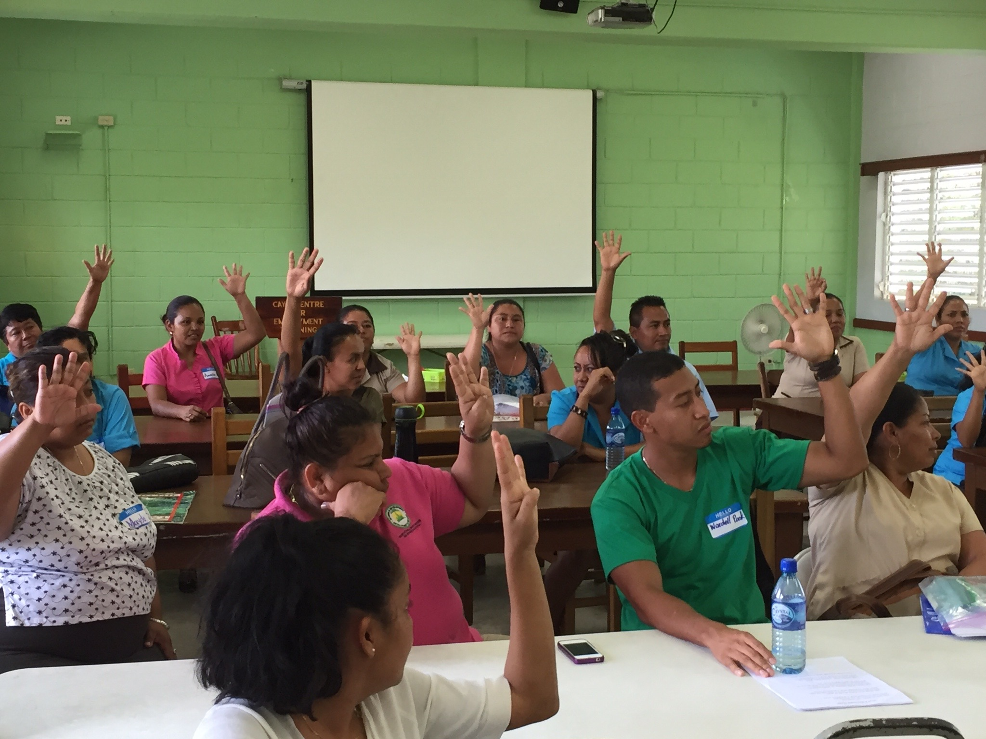
Belize teachers participating in Professional Development

BE A BELIZE STUDENT PARTICIPANT

- At least 300 children identified from Standard 4, 5 and 6
- Students to come from a cohort of schools to simplify transportation and to optimize the follow-up action, once the literacy camps are completed.
- Student incentives to become involved
- Teacher participants should be included from the schools where student participants are identified
- Opportunity to be a participant in August summer camps
- MOE CAYO District Office will co-ordinate the selection of students for the March camp

WHY WOULD A STANDARD 4, 5 OR 6 BOY OR GIRL
WANT TO ENROL IN THIS CAMP?

-four days of engaged learning with lots of fun, sports and activities
-hot lunch, morning and afternoon snacks supplied on site
-games, songs and dancing
-meeting new friends from other schools
-free neon-colored CAMP T-SHIRT
-complimentary reading, writing resources
-eligibility to earn a 500.00 (AM) scholarship for high school tuition
-eligibility to become a participant in an August community library camp
-school bus transportation provided for students outside San Ignacio area
-opportunity to improve personal reading and writing skills
-hear inspirational speakers that could inform your decisions about the
future
-a complimentary library card (and directions on how to best utilize it)

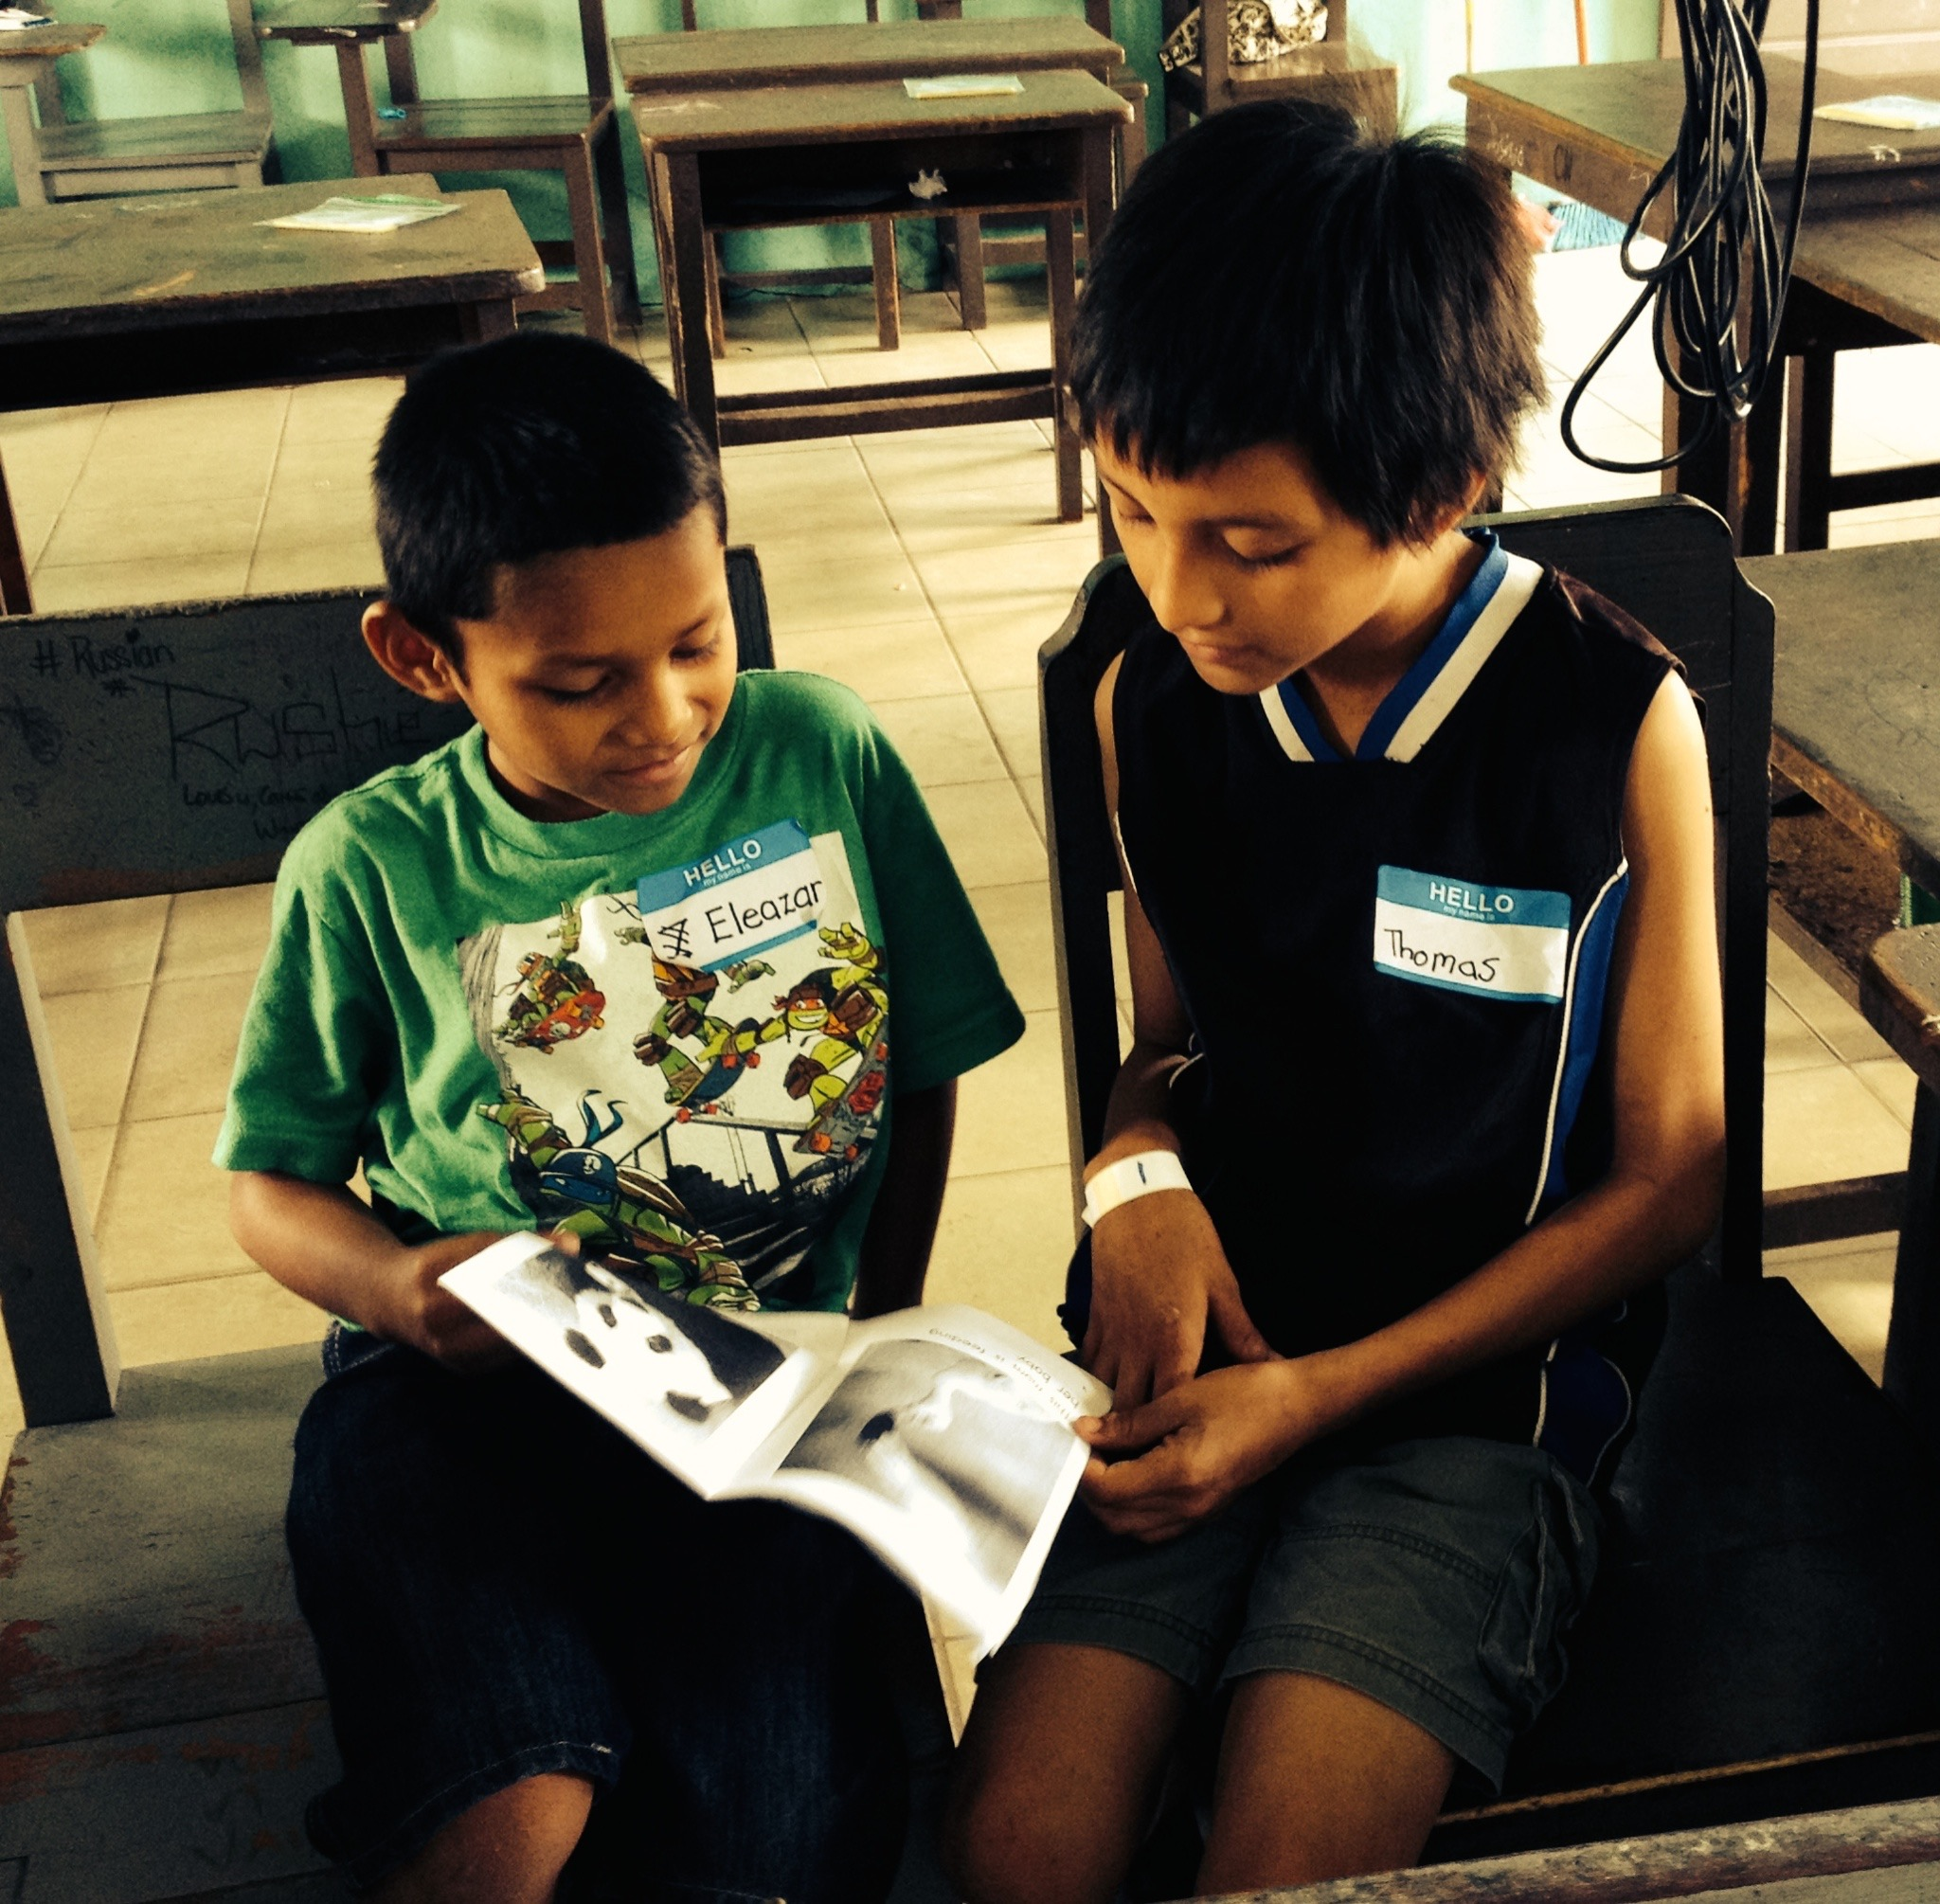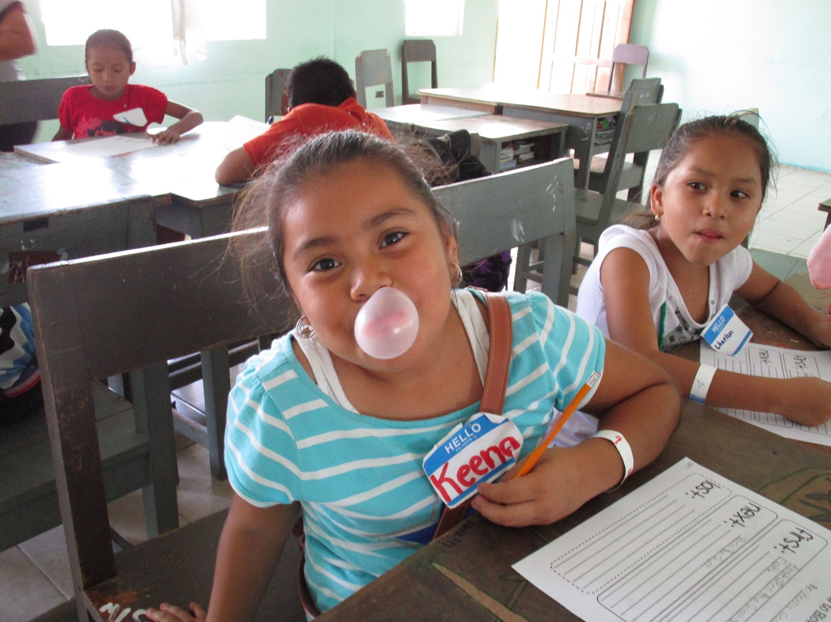
Belize students involved in literacy activities
VOCATIONAL TRAINING TEAM MEMBERS AND GROUP ASSIGNMENTS

- still being developed

VOLUNTRAVEL GROUP MEMBERS AND PARTICIPATION PLANS

