LITERACY ALIVE III PROJECT
RAINFOREST READING AND ADVENTURE CAMP 2016

MEDIA INFORMATION

WHAT HAPPENED IN BELIZE (CAYO DISTRICT) IN APRI 2016 TO SUPPORT COMMUNITY LITERACY ?
- The first annual RAINFOREST READING AND ADVENTURE CAMP provided an exciting teaching and learning initiative to support Belize teachers and students in improved reading and writing achievement.
- Over 20 Canadian literacy experts in the Literacy Alive III Rotary Global Grant initiative returned to Cayo to assist with strengthening literacy teaching and learning.
- A three day camp packed with learning and adventure ran March 29, 30, 31 . Resources and teaching strategies to support reading improvement modeled by Canadian leaders co-presenting with Belize educators who are leading student literacy improvements in their schools.
- Students learned about becoming better readers in a three day camp that integrated adventure and fun activities around a Rainforest theme.
- Belize teachers and public librarians learned more about strategies to use in classrooms that positively impact student progress in reading and writing.
- A celebration of literacy was held as a closing activity for the camp where over 300 participants engaged in a song and dance celebration singing “What a Wonderful World’ to capture the spirit of international friendship and peace and possibilities for good that come from peaceful collaboration between countries.

WHO PARTICIPATED in the RAINFOREST READING AND ADVENTURE CAMP?
- Over 250 children from primary schools across the Cayo district
- Children were recommended to participate by their school principals and teachers
- Student participants included children with serious reading difficulties, children who had never been away from their rural villages and others who were discouraged with their progress at school
- Parents of children participating were encouraged to attend
- Public Librarians from San Ignacio, Santa Elena and Benke
- Classroom teachers and administrators from over 20 schools
- Ministry of Education Cayo District office directors and literacy support leaders
- Community volunteers
- 23 Canadian literacy experts and community developer volunteers from Alberta, Canada
- Rotary volunteers from the Rotary Club of Red Deer, Canada and the Rotary Club of San Ignacio.

WHAT ACTIVITIES?
- Canadian Literacy Alive team provided all resources and leadership
- Students proceeded through learning stations focused on: Phonics, Reading, Writing and Comprehension
- Daily Rainforest adventure activities included sports and games for students
- Follow up professional development for educators (April 4,5) provided the Belize educators with training in effective literacy instructional skills, and sufficient training to operate literacy camps in local villages/towns. All resources to operate the camps was provided to the Belize participants.

WHY A READING AND ADVENTURE CAMP?
- Evidence of success with the concept in other countries
- Provides students with a quality reading intervention support system
- Provides teachers the opportunity to use resources and strategies that can be also used when they return to their home schools
- Method to share quality teaching and learning resources to many teachers in many schools.
- Belize educators learn about effective literacy support strategies at the same time that they can practice using them with student campers.
- The three day camp was a condensed model of a much larger camp that can be hosted by Belize communities during summer vacation blocks.
- Community members, including local public libraries, clubs/organizations engage in the literacy support process by transferring ideas, resources, and activities to Belize led initiatives.

HOW WILL THE CAMP OPERATE?
- All activities took place at Sacred Heart College in San Ignacio.
- Busses provided daily transportation to and from the camp for students who do not live in San Ignacio (town where the camp was hosted)
- Camp operated from 9:00 – 3:30 for three consecutive days.
- Each Canadian leader provided mentorship and coaching to a team of Belize educators and volunteers (referred to as Literacy Teaching Cohorts).
- Daily de-briefings for Camp Leaders followed dismissal of students
- Students circulateed between a series of learning stations

SPECIAL FEATURES
- Students received reading support materials
- Snacks and lunch were provided by local community volunteers.
- Website was developed to house all literacy support materials for friendly access by camp participants.
- The Rainforest Reading and Adventure Camp was part of the activities of a project called Literacy Alive III. In the past six years Literacy Alive I and II operated in Cayo and focused on a variety of activities to assist teachers in schools with effective resource development and teaching strategies. The first two phases of the project evolved into Literacy Alive III and the student reading and adventure camp concept.

WHO SPONSORS THE CAMP?
- Rotary Club of San Ignacio works with the Rotary Club of Red Deer, Alberta Canada in a collaborative Literacy Alive project where both clubs provide source funding which is matched by Rotary International to support costs of the project (over $50,000 US).
- Funding goes toward development of materials, camp costs, professional development costs and support for Canadian literacy leaders to travel to Belize.
- Sacred Heart College in San Ignacio has partnered with the project to generously provide the facility to operate the camp.
- The Cayo Ministry of Education Office, provided support in communication, promotion and co-facilitation of the project activities.

HOW DOES THIS PROJECT SUPPORT LITERACY IMPROVEMENT IN BELIZE?
- Augments existing training and experience of local educators
- Assists in developing strategies to engage local communities (individuals, parents, community organizations, public libraries) in literacy support
- Provides many reading/writing teaching and learning resources for local schools
- Sets up a model that can be duplicated anywhere in Belize at reasonable cost
- Provides support materials to host camps and provide professional development to teachers and community volunteers in the areas of literacy learning

LITERACY ALIVE PROGRAM CONTACTS:
- Dr. Lynne Paradis, Literacy Alive Project Director: Rotary Club of Red Deer, Canada paradislynne@gmail.com cell: 587 877 8512
- Aki Fukai, President, Rotary Club of San Ignacio.
- Mr. Luis Carballo, Director, Ministry of Education, Cayo District office
- Mrs. Isaura Williams, Literacy Director, Ministry of Education, Cayo District Office

BENEFITS OF THE LITERACY ALIVE III PROJECT

- Belize educational and community participants increase leadership capacity to improve literacy practices in local schools/communities
- Red Deer volunteers are engaged in teaching/learning activities that bring added value to their vocations as educators
- Building of goodwill, friendship and shared joy between countries
- Development of follow up support projects between Red Deer, Canada and Belize
- Over 50,000 American dollars added to the Belize economy (beyond travel costs for the project) by volunteers (hotels, car rental, food, leisure activities, purchase of teaching resources, all camp supplies, tourism).
- Addition of rich teaching resources to over 20 participating schools
- Belize Ministry of Education Director for the Cayo region was awarded a Paul Harris Fellowship for the outstanding work and support he has provided over the past six years for the Literacy Alive initiatives led by the Rotary Club of Red Deer.
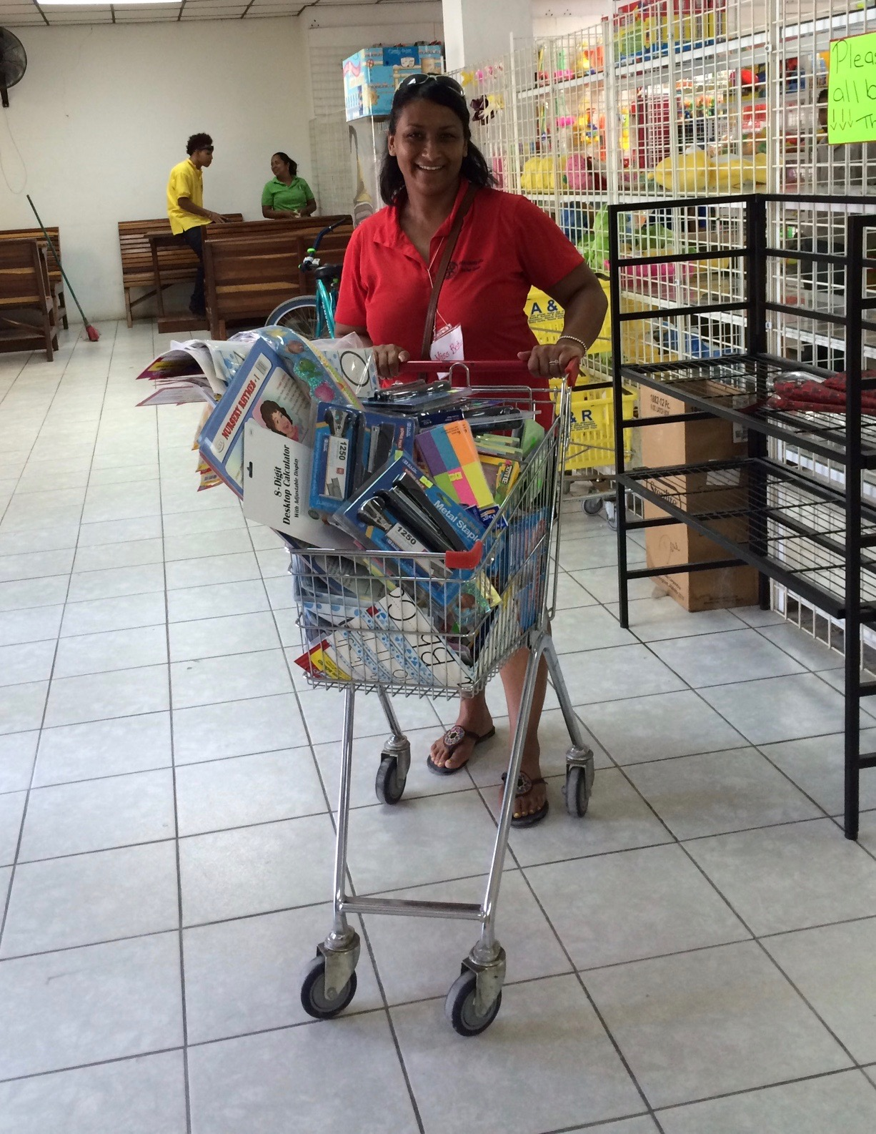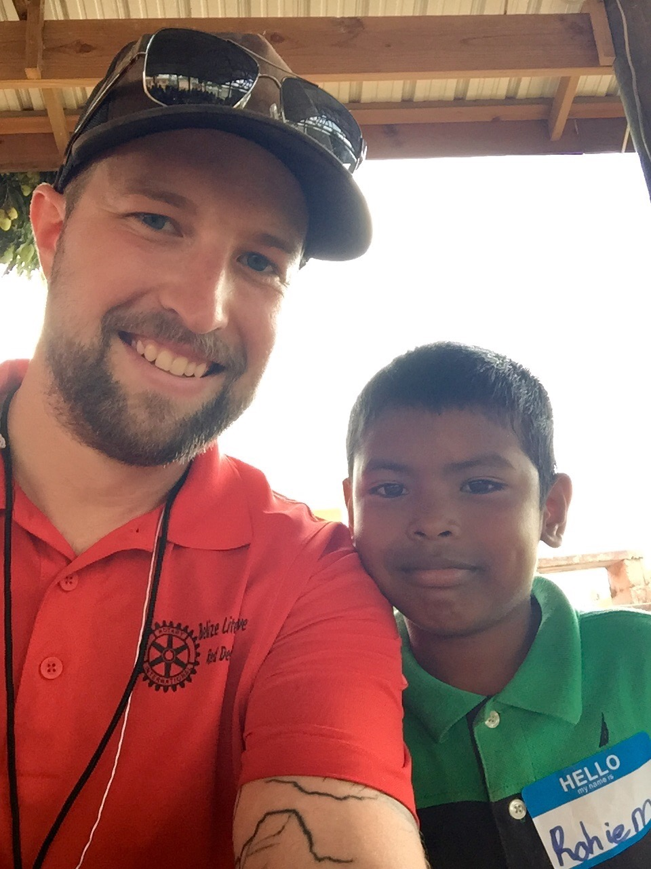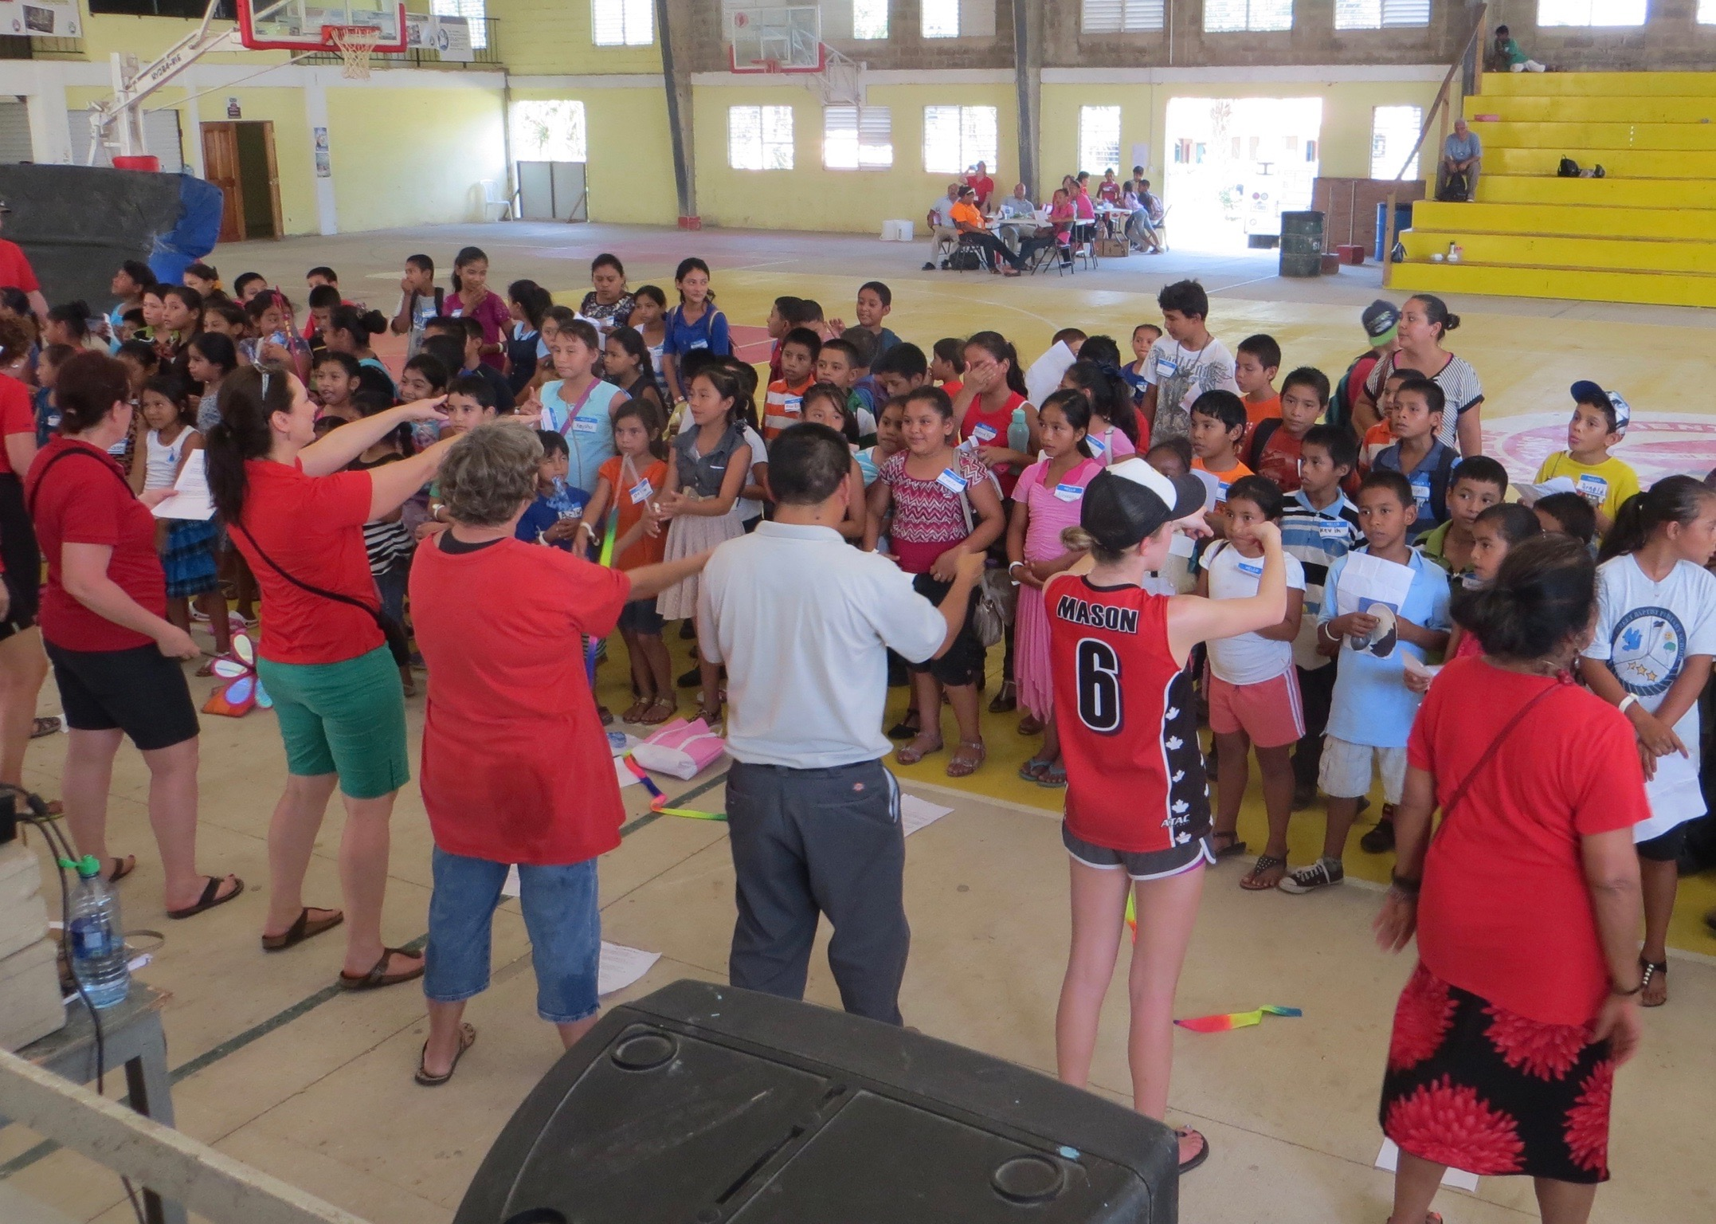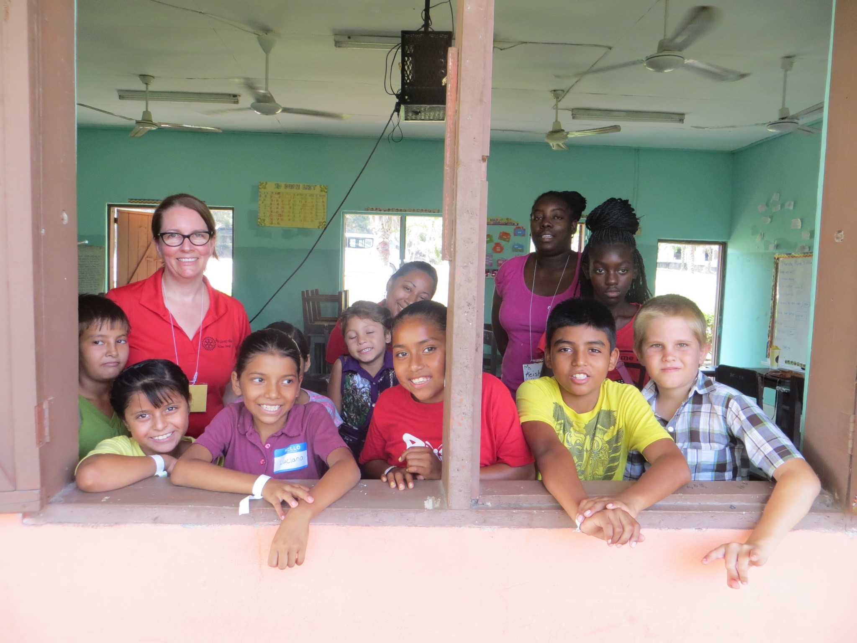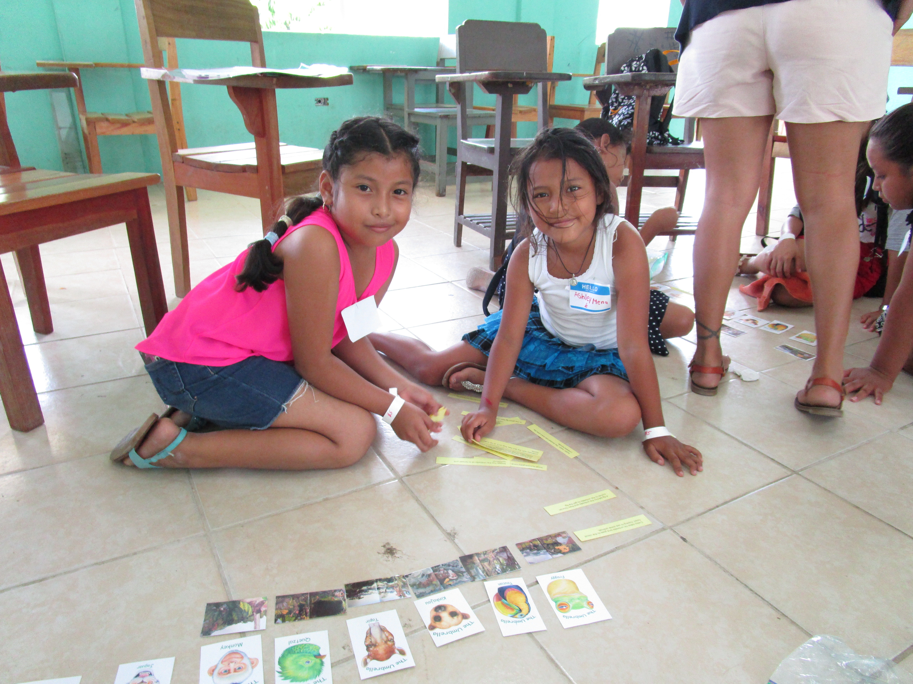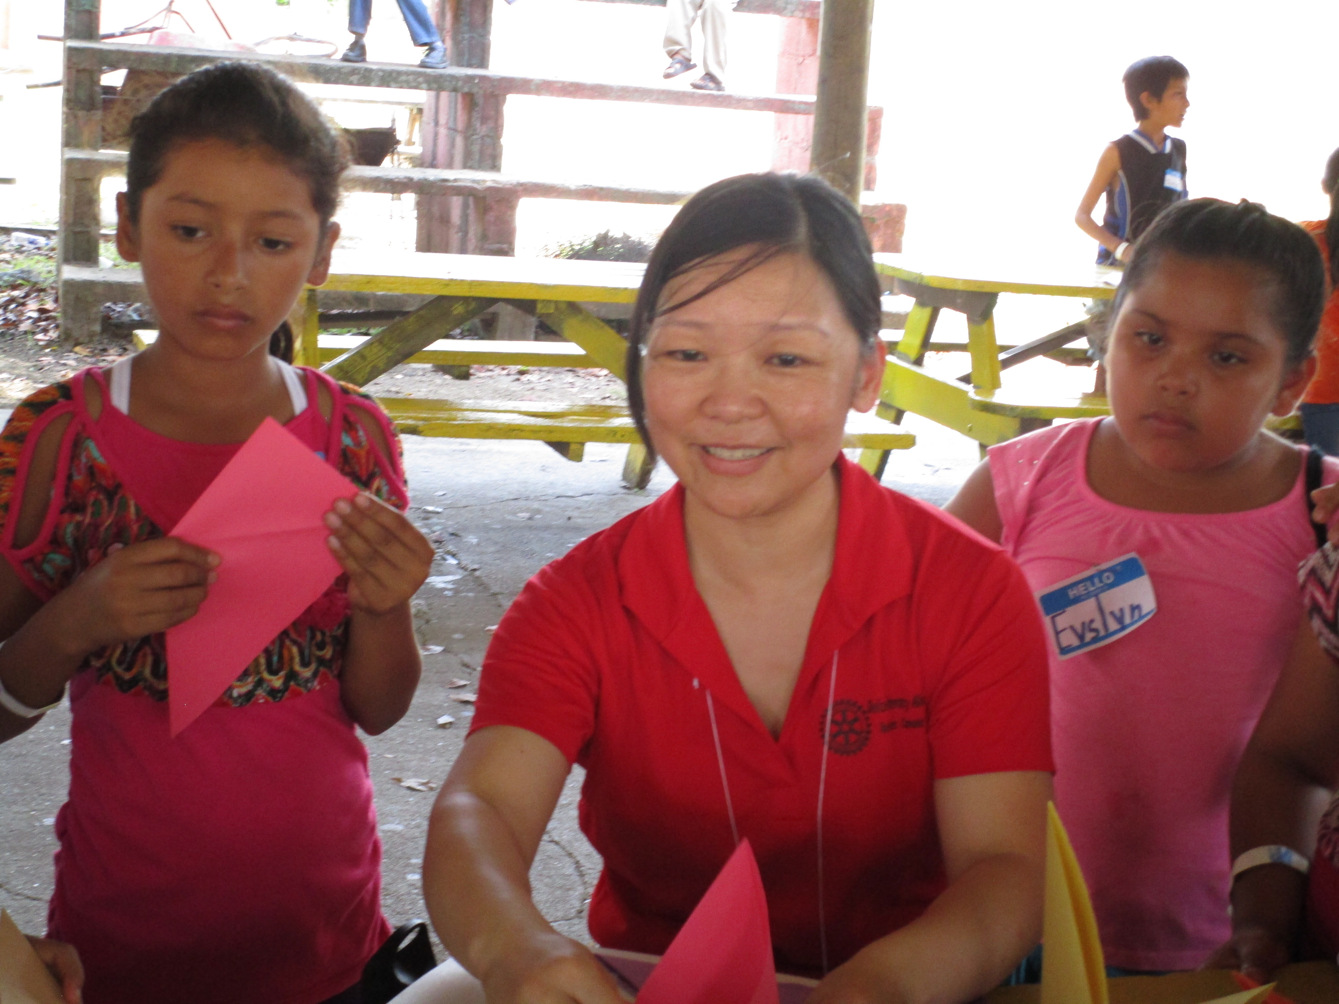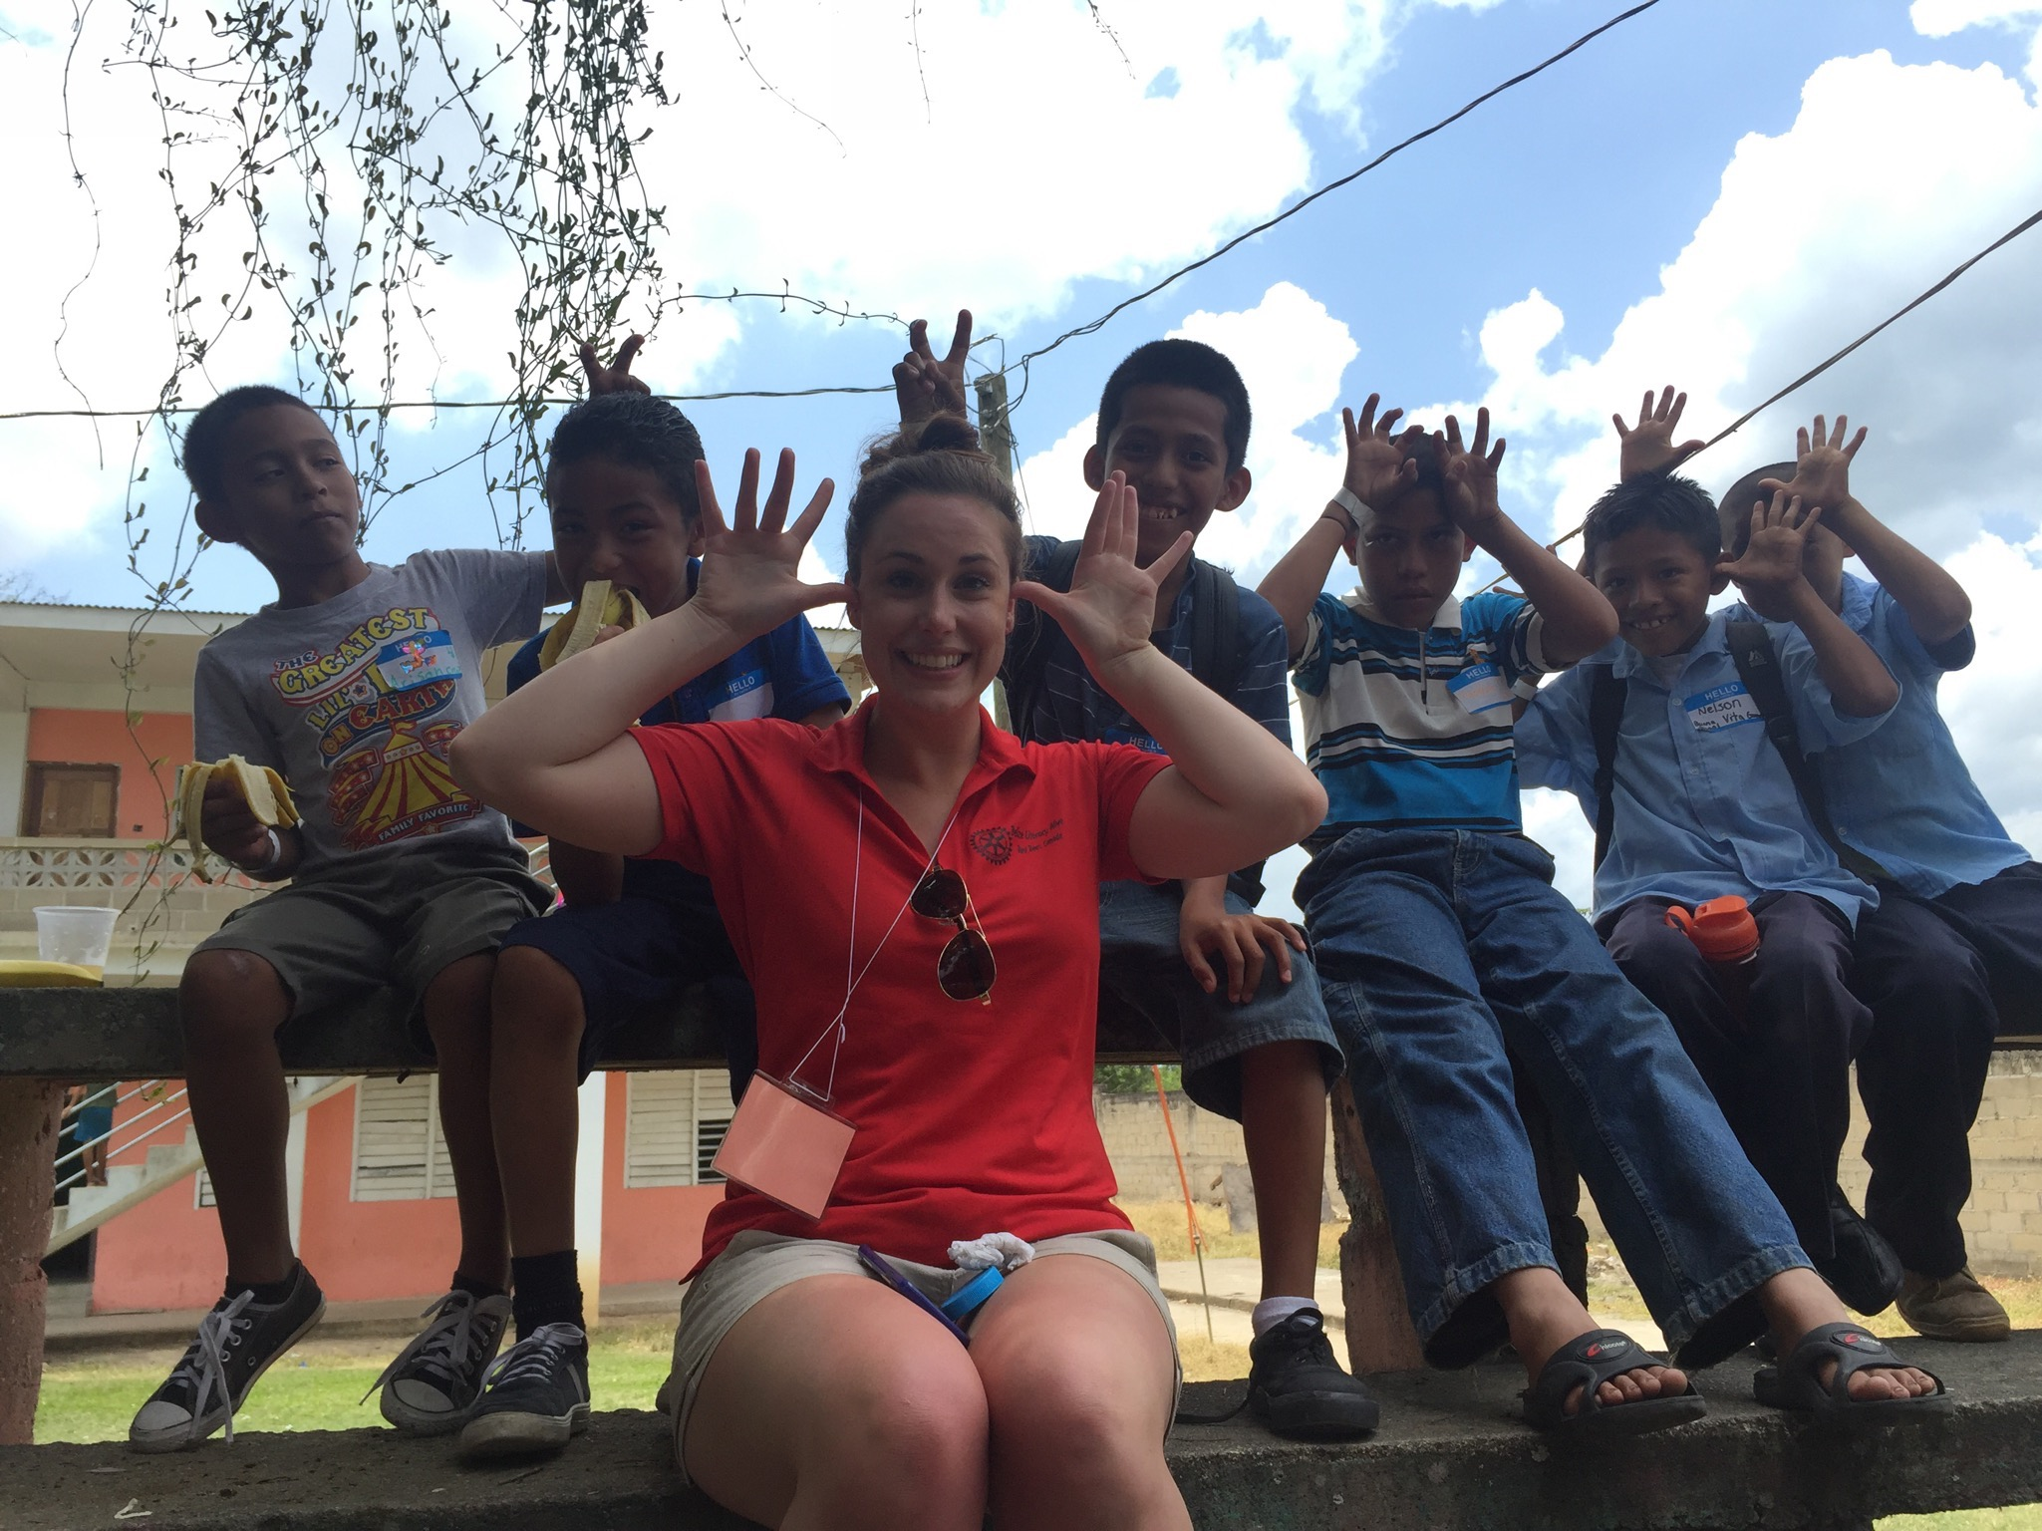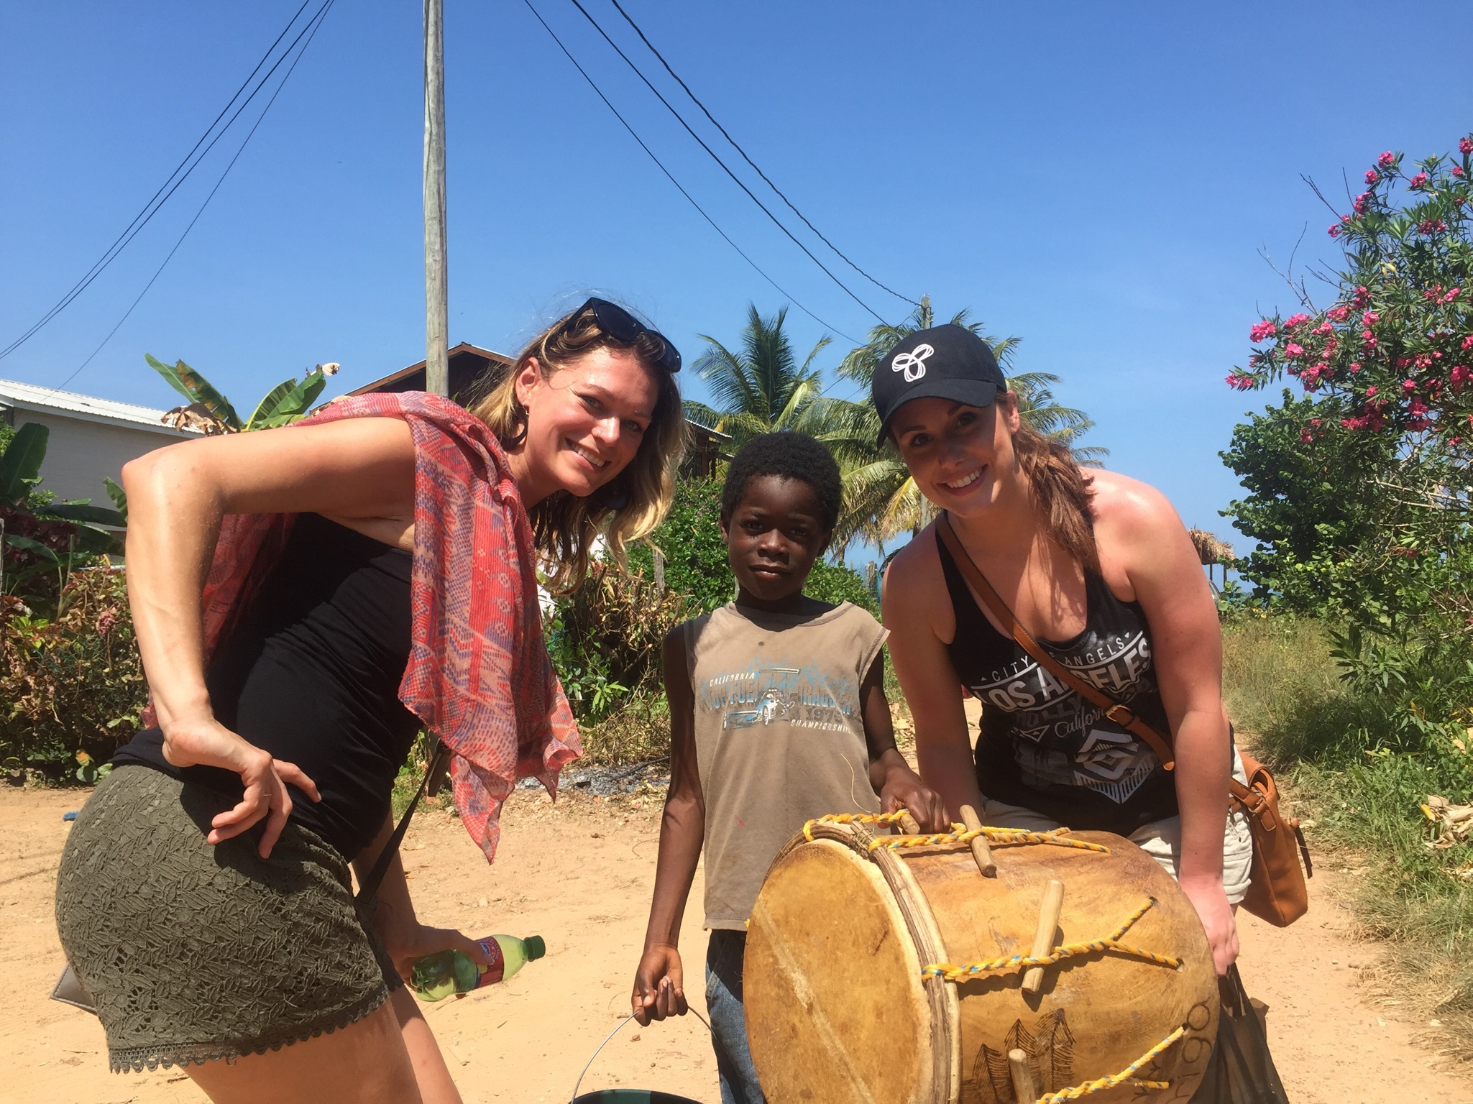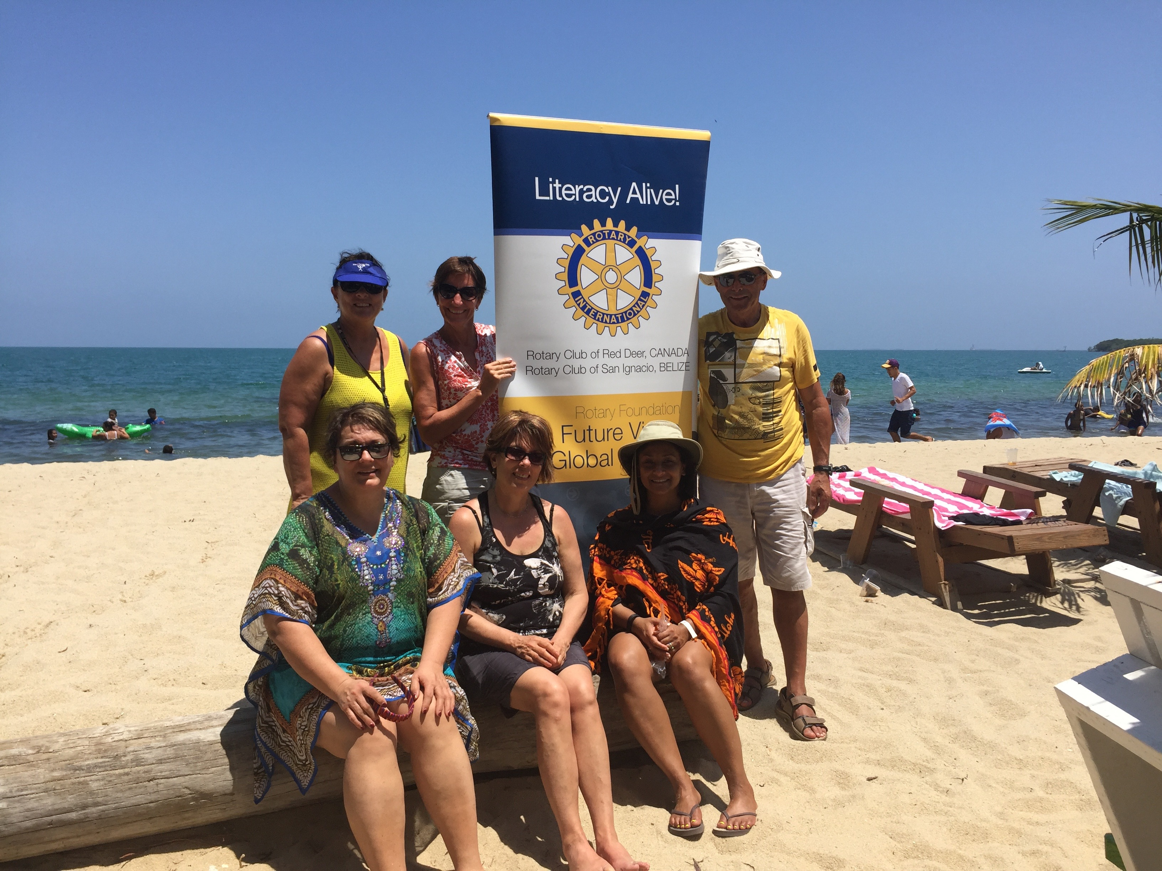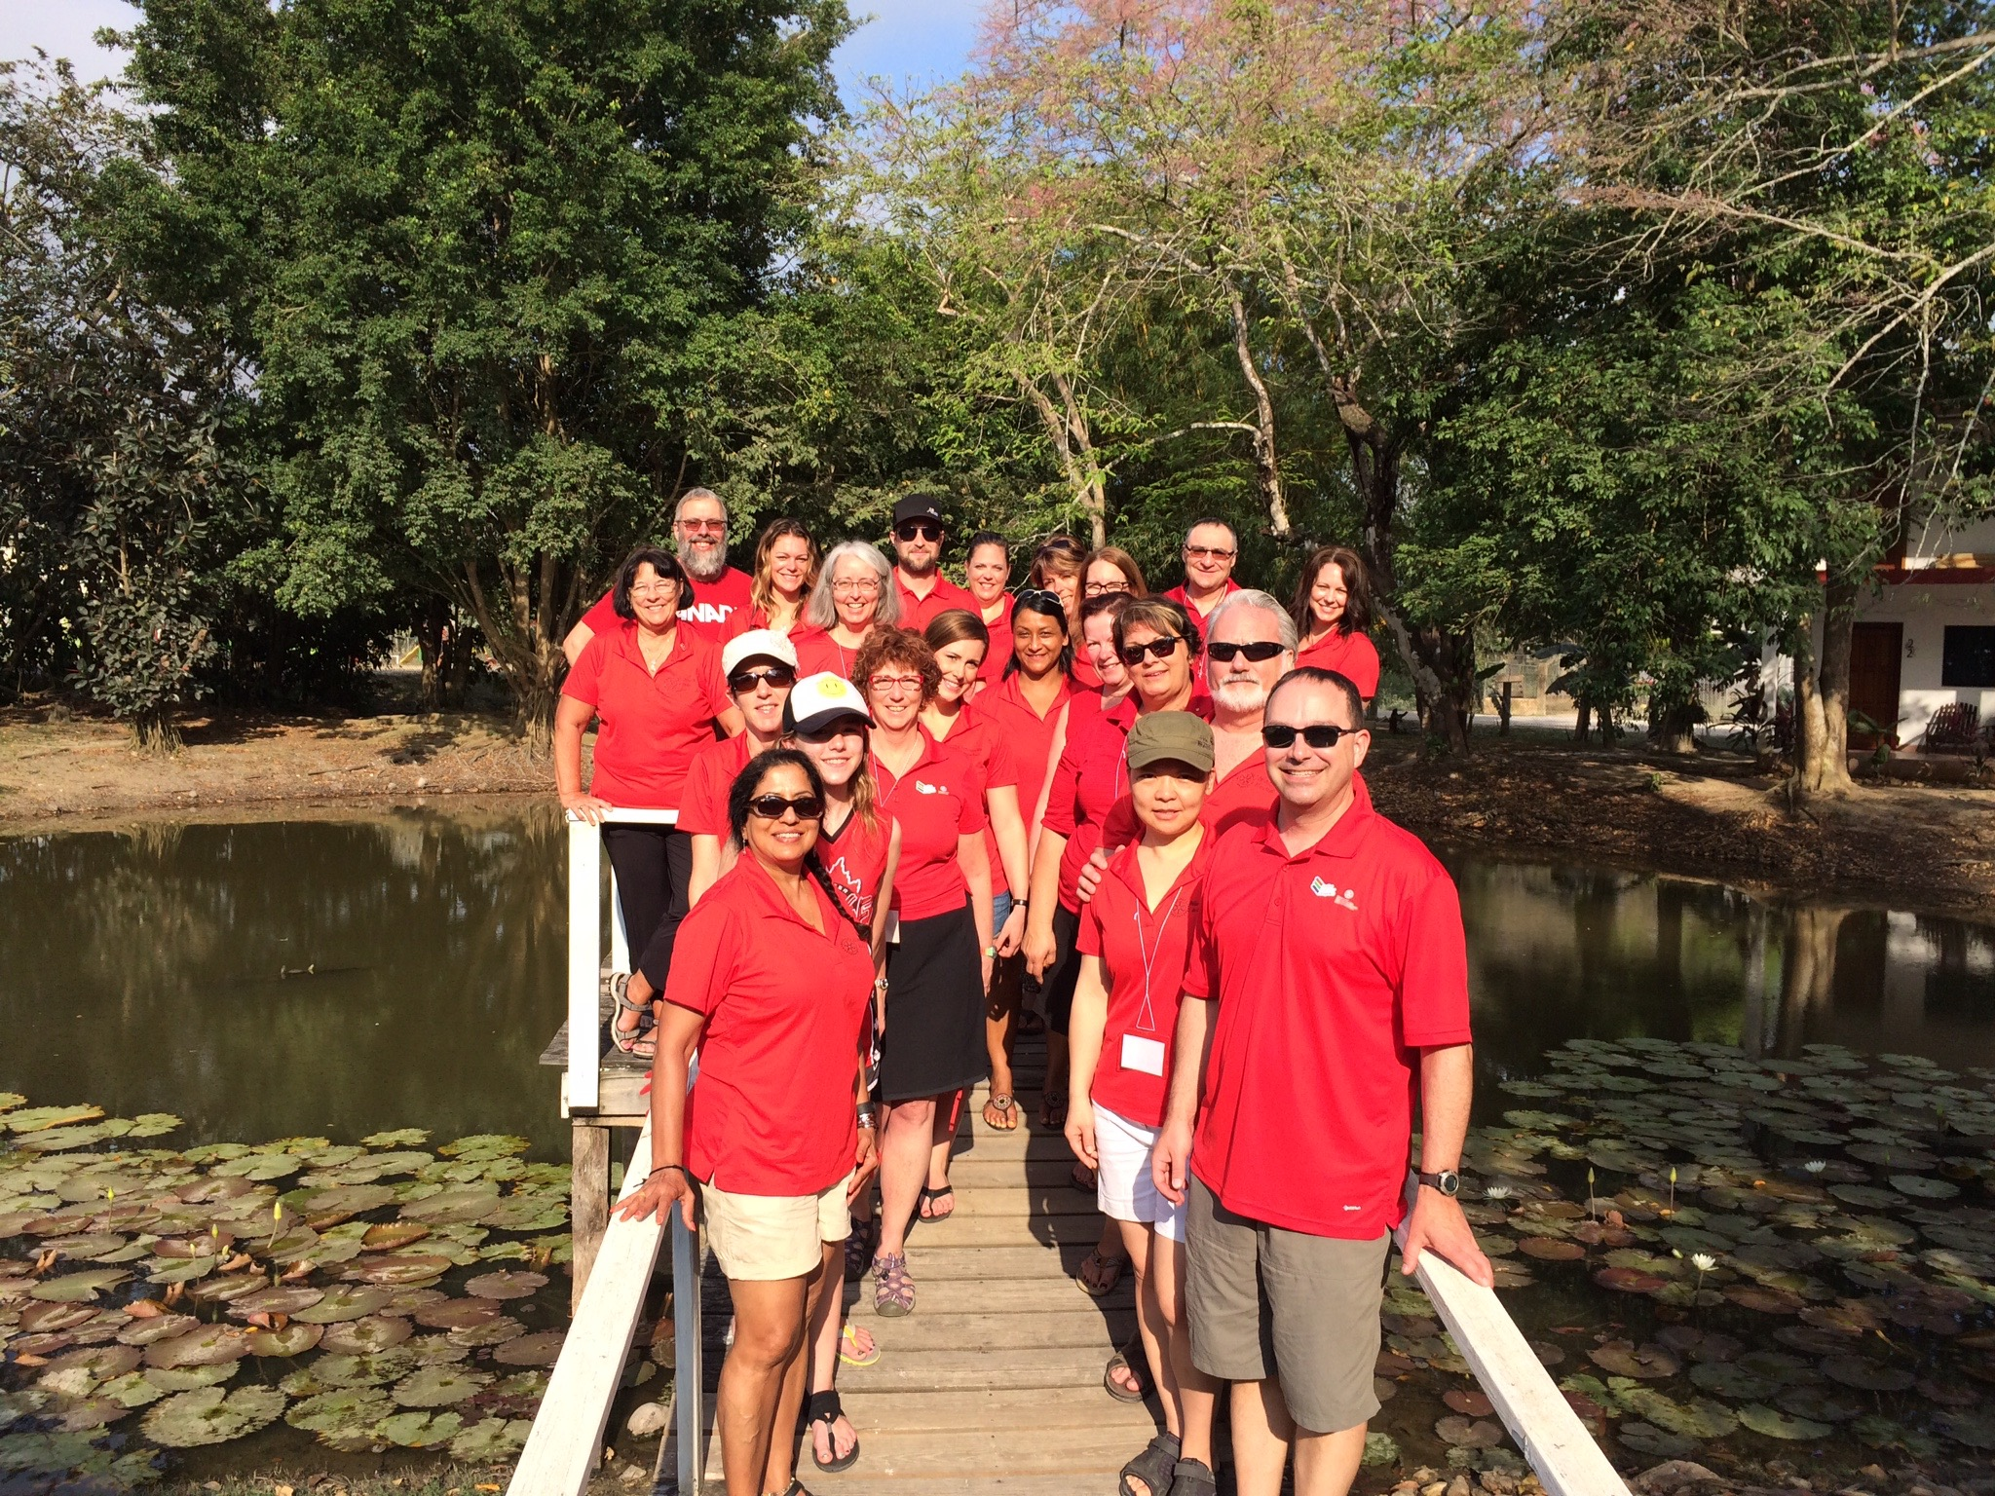

LIST OF Alberta Volunteer PARTICIPANTS

Lynne Paradis
Rebekah Seidel
Judith McIntyre
Donna Leontowicz
Michele Soltys
Purnima Lindsay
Cathy Sather
Doug Sather
Connie Brown
James Brown

Grace Zhang
Andre Lachance
Crystal Mason Brea Mason
Rita Di Placido
Nick Di Placido
Amanda Chartrand
RJ Willms
Tarah Callin
Shannon Eremenko
Della Lastiwka
Grant Lastiwka

